Power law transformations
Code:
import cv2
import numpy as np
image = cv2.imread('kol.jpg')
if image is None:
exit()
gray_image = cv2.cvtColor(image, cv2.COLOR_BGR2GRAY)
gray_image = np.float32(gray_image)
gamma = 1.5
c = 255 / np.max(gray_image) ** gamma
power_law_image = c * (gray_image ** gamma
power_law_image = np.array(power_law_image, dtype=np.uint8)
cv2.imshow('Original Image', image)
cv2.imshow('Power Law Transformation', power_law_image)
cv2.waitKey(0)
cv2.destroyAllWindows()
Code Explanation:
- The image 'kol.jpg' is loaded using cv2.imread().
- The image is converted to grayscale using cv2.cvtColor() to simplify the processing.
- The grayscale image is converted to float32 to avoid issues during the power-law transformation.
- A power-law transformation is applied using the formula Inew=c×(Iold)γI_{\text{new}} = c \times (I_{\text{old}})^\gammaInew​=c×(Iold​)γ, where:
  - ccc is a scaling factor calculated based on the maximum pixel value and the chosen gamma.
  - γ\gammaγ is the exponent, set to 1.5 in this case, controlling the contrast enhancement.
- The result of the transformation is converted back to uint8 to match the image format for proper display.
- The original and transformed images are displayed using cv2.imshow().
Output:
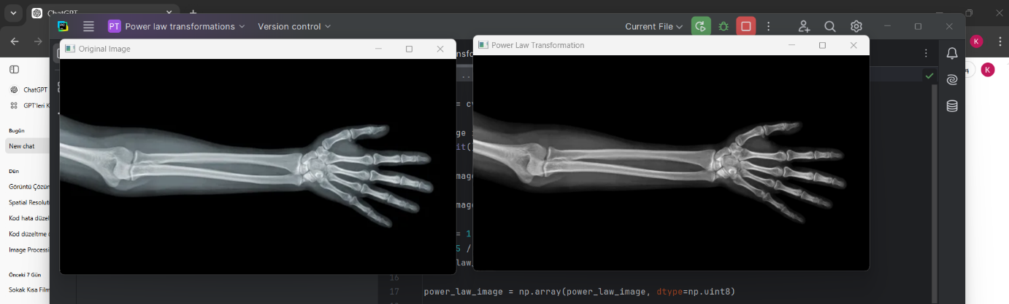

Report:
This code applies a power-law transformation (also known as a gamma correction) to an image. Power-law transformations are commonly used in image processing to enhance or suppress the brightness levels of an image. By adjusting the exponent γ\gammaγ, we can either lighten or darken an image.
The transformation is defined as:
Inew=c×(Iold)γI_{\text{new}} = c \times (I_{\text{old}})^\gammaInew​=c×(Iold​)γ
Where:
- IoldI_{\text{old}}Iold​ and InewI_{\text{new}}Inew​ are the original and transformed pixel intensities, respectively.
- γ\gammaγ controls the intensity transformation. If γ>1\gamma > 1γ>1, the image becomes lighter, while if γ<1\gamma < 1γ<1, the image becomes darker.
- ccc is a scaling factor ensuring that the output image stays within the 0-255 pixel value range.
In this code, the chosen γ=1.5\gamma = 1.5γ=1.5 increases the brightness and contrast, making the image appear lighter. The power-law transformation is useful for adjusting the dynamic range of images, especially when working with images that are either too dark or too bright. After the transformation, the original and modified images are displayed for visual comparison.

